Final Report: Using Machine Data to Predict Video Game Sales
Alvin Tran
School of Information, San Jose State University
Big Data Analytics and Management
Professor Prateek Jain
May 5, 2023

Motivation
Video games have become one of the fastest growing media markets in the world. Even though the market revenue may have shrunk a little bit from its COVID-19 pandemic high of $192.7 billion to $184.4 billion (Totilo, 2022), it still represents a multi-billion-dollar industry that is tempting to break into or secure. Modern game developers have a range of options for pursuing the ambitions ranging from independent developers scrounging for funds from their own investments or appealing to audiences or donors via crowdfunding campaigns to giant publishers sinking Hollywood level budgets to develop, produce, and market their products (Bramble, 2022). The dramatically lowered bar of entry to the video game market means that any individual or group with the means, dedication, skills, and creativity can assemble the resources or creativity to develop, publish, and promote a successful video game.

Problem Statement
The diversity of options when it comes to game development does present a significant issue though. With so many options to choose from ranging from platforms to genre, gamers are inundated with choices in how to pursue their gaming fixes. This means that game developers need to start early in figuring out how to differentiate their future projects from their competitors. Also, the choice between either making video games available across multiple platforms or exclusive to a single platform is also a decision many developers will need to make early in the development phase. Even though the success of video game consoles is often thought to “largely been influenced by the ability to garner third-party support” (Srinivasan & Venkatraman, 2010, 662), the requirements that publishers need to develop exclusives has often swung back and forth between exclusives and multi-platform offerings; Sony would assemble an impressive library of exclusives for the Playstation 4 and Playstation 5, which became one of their strongest selling points over Microsoft’s Xbox One and Series X, but a combination of the PS5’s surprisingly underwhelming sales due to shortages and Microsoft and Sony both deciding to pursue porting their console exclusives to PC meant that the pendulum has swung back towards multi-platform games (Balasubramanian, 2022). Nevertheless, developers will have to determine early the direction or development choices they desire to pursue to ensure a smooth development process that leads to a video game than can be successfully funded, developed, published, marketed, and sold to consumers.

Methodology
The data was assembled from a dataset called “Global Video Game Sales & Ratings” from a Kaggle user named The Devastator. “Global Video Game Sales & Ratings” was updated as recently as February of 2023 and scrapes its data from Metacritic to provide “insight into global video game ratings and sales” (The Devastator, 2023). Even though The Devastator included a csv called “Clean Data 2”, I chose to start work from the aptly described “Raw Data”.
The first cleaning I did dropping everything with an NAN. After that, I dropped every game released before 2012 because I wanted to focus on video games released for platforms part of the current 9th generation and immediate predecessors in the 8th generation. To explain the different generational divides in video game consoles, 8th generation describes consoles first released around 2012, starting with Nintendo’s Wii U, and then followed by the Playstation 4, Xbox One, Nintendo 3DS, Playstation Vita, and Nintendo Switch (VG Legacy, 2023). Even though it is a dramatic culling of the data, I had wanted to stick to only using current generation consoles to make sure the data remains relevant. I also dropped every game that was not for the Playstation 4, Wii U, Xbox One, Playstation Vita, Nintendo 3DS, or PC.
Once that was done, I selected the "Name", "Platform", "Year_of_Release", "Genre", "Publisher", "Global_Sales", "Critic_Score", "Developer", and "Rating" columns for my new clean data frame. To make the data frame easier to work, I also converted Global_Sales from shorthand (i.e.: 12.61) to long hand (12610000.0). I then converted the float values to ints. Once that was all completed, I exported the data frame as a CSV file and exported it to SQL as well.
After that came the task of setting up multiple examples of machine learning models. The first models that came together coherently were two different supervised learning models; a Balanced Random Forest Classifier and an Easy Ensemble AdaBoost Classifier. A Balanced Random Forest Classifier is a class that “performs random undersampling of the majority class” (Brownlee, 2021a). The Easy Ensemble AdaBoost Classifier is an algorithm “created from decision trees added sequentially to the model” and “involves using very short (one-level) decision trees as weak learners that are added sequentially to the ensemble”. (Brownlee, 2021c). While the Balanced Random Forest Classifier randomly undersamples each sample to balance, the Easy Ensemble AdaBoost Classifier works by fitting a classifier on the original dataset and then fitting additional copies of the classifier on the same dataset and adjusts the weights of incorrectly classified instances.
The next set I used was a series of resampling models that focused resampling the data. The two primary methods of resampling are oversampling or undersampling. Oversampling is the act of creating “duplicate examples from the minority class” Brownlee (2021b) while undersampling is to “delete examples from the majority class” Brownlee (2021b). These two methods are used to “the problem of class imbalance” and prevent the algorithm from ignoring the minority class Brownlee (2021b). Resampling the data is important to prevent any model from ignoring underrepresented games, especially games that are part of underrepresented genres, ratings, or platforms.
After that, I tried using Cluster analysis, or clustering; “an unsupervised problem of finding natural groups in the feature space of input data” (Brownlee, 2020). Cluster analysis works by working out natural groupings in data. Since video games can be easily groups by traits such as rating, platform, or genre, this made it a tempting model to pursue.
I also assembled some workbooks using Tableau. Even though Tableau workbooks do not use much in the way of machine learning, it still helped to establish some context and basis for the data. Even though I had exported the cleaned game data to MySQL, the fact that my SQL syntax and manipulation is not fresh meant that my ability to manipulate that data is limited. Tabeau offers a higher level of interface that allowed me to relearn it at a faster pace than SQL. I arranged the data by traits such as platform, rating, and genre, and then I broke it down further by Year of Release so I could easily track high points and low points in sales and releases over the period between 2012 and 2016.

Analysis and Results
The Balanced Random Forest Classifier predicted the platform, rating, and genre with an accuracy score of 35.32%, 72.42%, and 39.99%.
The Easy Ensemble AdaBoost Classifier predicted the platform, rating, and genre with an accuracy score of 41.75 %, 50.17%, and 28.97%.
The Balanced Random Forest Classifier and Easy Ensemble AdaBoost Classifier models were the most coherent; being able to predict traits such as the platform, audience rating, and genre of a set of video games.
The Naïve Random Oversampling managed to predict the platform, rating, and genre predicted the platform, rating, and genre with an accuracy score of 22.42 %, 32.42%, and 11.85%.
The Synthetic Minority Oversampling TEchnique or SMOTE predicted the platform and rating with an accuracy score of 18.90% and 28.84%. Unfortunately, the SMOTE method failed to do the same for the genre, throwing up the error that “Expected n_neighbors <= n_samples, but n_samples = 2, n_neighbors = 6”.
The undersampling also seemed to be not as coherent when it comes to the accuracy scores. Even though the program insists that the accuracy score is 0, the platform, rating, and genre were supposedly predicted with an accuracy score of 24.12%, 24.13%, and 11.18% on the imbalanced classification reports.
The Combination (Over and Under) Sampling was the least coherent of the models. Not only did it have the same issue with the program supposedly showing an accuracy score of 0 while showing accuracy scores of 26.13% and 35.09% on the imbalanced classification reports for the platform and rating respectively, but it also ran into the same error as the undersampling with the “Expected n_neighbors <= n_samples, but n_samples = 2, n_neighbors = 6” error for the genre.
The SMOTE, undersampling, and Combination (Over and Under) Sampling models would selectively work for different traits and some of them would be incoherent in comparison to the Balanced Random Forest Classifier and the Easy Ensemble AdaBoost Classifier.
The clustering algorithm was modified from an old code I had lying around. While the code functioned smoothly, the fact that my syntax and data manipulation skills were not that fresh meant that I was not able to glean as much information as I would have liked. I was able to group the data together, but the lack of fresh experience with the syntax meant that my command of the data was not as impressive as I had hoped. I attempted to drop and set different variables, but none of the outcomes were to my liking.
I was able to glean some trends from the Tableau workbook data. One note to keep in mind is that the data only went up to 2016, meaning that the pandemic highs were not considered. Even so, the slight declines in sales across the board from 2015 to 2016 probably contributed to the astronomical jump when the pandemic hit in 2020.
The workbooks also showed that the Playstation 4 was the highest seller when it came to video games from 2012 to 2016, routinely outselling video games compared to its compatriots. It would reach its highest in 2014 with 80,729,998 games sold. Even its largest competitor, the Xbox One, could only sell 47,070,000 games in its own high in 2014. The lowest seller would be the Playstation Vita, which could only sell 13,150,000 games in 2012 at its highest.
The workbook also demonstrated that Mature rated games outsold games at a high of 85,279,999 units in 2014 versus games intended for younger audiences; no doubt, a result of the fact that the intended target audience had the disposable income to afford videogames. In another observation, Everyone rated games sold 39,750,000 units in 2015, making it second place. E10+ games were the lowest selling games, being only able to reach a high of 21,910,000 games in 2015.
When it came to genre, action genre games sold at the highest numbers, shifting 56,530,000 examples in 2014. Only shooters came close to reaching the peak set by the action genre, reaching 44,270,000 units in 2014. The lowest performing genre was the puzzle genre, which could only sell 1,190,000 games at its peak in 2014.
In the four-year period between 2012 and 2016, the lowest year would be 2012, which saw only 87,849,999 games sold. In contrast, the best performing year would be 2014, which saw the whopping sales of 171,049,998 video games during the year.
The counts of the games also proved to be an interesting observation. For example, the PS4 saw the most releases, with 92 games released in 2016 alone. In the same year, the Xbox One reached its own peak with 55 releases. The Wii U saw the lowest number of releases; only having 27 titles available at its highest in 2013.
When observing audience ratings, Mature and Teen games peaked in 2014 with 70 titles, but while Mature games reached that high again in 2016, the number of Teen releases dropped to 63 in the same year. The lowest count of ratings belongs to the E10+ category; only seeing 39 titles with the rating at its highest in 2014.
Action games peaked in releases in 2015 with the release of 74 titles under the genre. Shooters could only catch up to that score with 36 titles in 2016. Meanwhile, puzzle games were the most underrepresented genre, only seeing a grand total of 3 titles each in 2013 and 2015.
The lowest point of game releases was in 2012, which only saw the release of 124 titles. The number of releases would keep on climbing until 2016, which saw the release of 212 games.

Discussion
The first thing I want to note about my dataset is that it is severely out-of-date. Even though I had originally selected it for its completeness when it came to listing different datapoints for each video game, it not only lacks data for video games released after 2016, but it also lacks video games released for the latest consoles such as the Nintendo Switch, PlayStation 5, and Xbox Series X. This also means that the high sales that came with the COVID-19 pandemic were not considered.
The data also does not consider the number of consoles sold; only focusing on video games. While the number of consoles sold is well beyond the scope of the data, it should be considered whether console sales drive game sales. One of the PS4’s largest selling points over its competitors was the library of Playstation exclusives, and the endemic shortages that afflicted the launches of the latest generation of consoles such as the PS5 and Xbox Series X has encouraged both Sony and Microsoft pursue PC ports of their console exclusives (Balasubramanian, 2022). It also does not consider that even though the two companies have pursued PC ports, both businesses desire to “operate more and more like multimedia ecosystems, diversifying their businesses across a variety of screens and content types in a way most reminiscent of streaming TV”, which would make selling to repeat customers easier (Statt, 2021). The current data does not account for the multi-media strategies that large game publishers wish to pursue, meaning that non-video game products such as animated series, merchandise, or downloadable content are not taken into consideration.

Conclusion
My attempts at using different algorithms and models were not very effective. Of the different algorithms and models, only the Balanced Random Forest Classifier for the age rating had a balanced accuracy score of over 70%. The rest rand a gauntlet ranging from as low as 11% to just scratching 30% to 50%.
Despite the notable gaps and obsolescence of the data, some insights could be gleaned from the current data. First off, PS4 games had dominated the period from 2012 to 2016, having made games for the Sony platform and its successor a tempting benchmark to reach for. The Wii U, on the other hand, seemed to be a console that was avoided by both audiences and developers, seeing the lowest sales and lowest number of releases. Second, the dominance of sales for Mature rated games over their more child-friendly contemporaries demonstrates that games aimed at adult audiences may tend to be the big releases and big sellers. Nevertheless, the fact that Everyone rated games take second place means that there is still a market for family games aimed at children, but the game and the marketing must figure out how to not only appeal to children, but also appeal to the parents who will be the ones buying the games for their households. E10+ games seem to occupy a niche where they are not quite suitable for all audiences, yet do not quite reach the criteria to be considered a Teen game, making it struggle in terms of sales and releases. Next up, action games have been the biggest genre in terms of releases and sales for the period, followed by shooters. Meanwhile, the puzzle genre not only saw a low number of releases, but it also saw a low number of sales.
Looking at this data may cause one to predict that a Mature action game for the Playstation 4 would be the biggest seller. Indeed, many factors made the Playstation 4 one of the biggest consoles of the 2012-2016 period; in particular, the PS4’s exclusives had made it one of the reasons why video games intended for the PS4 outsold video games for its competitors by wide margins throughout the four-year period. Combined with an audience with the income to purchase the game and a genre that would appeal to a large audience, it would be easy to see why so many developers had pursued that path in game development. It would also be easy to predict that an E10+ puzzle game for the Wii U is a title choice that developers would try to avoid; the dearth of choices in titles and third-party support for the Wii U and a small niche in terms of genre and intended audience would signal that a developer pursuing such a title would either be aiming at a small audience or are pursuing personal or artistic choices that would not be met by chasing after the large sales or releases.
One aspect of video games that developers should also be concerned about is the increasing number of releases over the years. From 2012 to 2016, the number of releases jumped from 124 up to 212; a 70.97% increase in the number of titles available. Even though an increase in releases does not mean a decrease in sales, as seen in the Tableau workbooks, developers should take care to differentiate their offerings when marketing their titles; this would be critical during periods of high number of releases, when gamers would have multiple options to satisfy their fixes.
The lowered barrier of entry makes entering the video game market a deceivingly easy money-maker. With so many different options ranging from self-funding or crowdsourcing all the way up to convincing a large publisher to throw Hollywood-level budgets at them, a developer with the vision, skills, dedication, and technology could fund, develop, publish, and market a successful title in terms of both sales and critical acclaim. The lowered bar of entry also means that their titles would be competing against a multitude of competitor titles, all with different funding, development, or marketing choices or methods. As a result, success means that game developers need to decide early how to differentiate their vision from their competitors, and then commit to those early development choices.

References
Balasubramanian, K. (2022, June 30). The Decline of Platform Exclusivity. Gameopedia. https://www.gameopedia.com/decline-of-platform-exclusivity/
Bramble, R. (2022, July 13). How Much Does It Cost To Make A Game In 2022? GameMaker. https://gamemaker.io/en/blog/cost-of-making-a-game
Brownlee, J. (2020, August 20). 10 Clustering Algorithms With Python. Machine Learning Mastery. https://machinelearningmastery.com/clustering-algorithms-with-python/
Brownlee, J. (2021a, January 5). Bagging and Random Forest for Imbalanced Classification. Machine Learning Mastery. https://machinelearningmastery.com/bagging-and-random-forest-for-imbalanced-classification/
Brownlee, J. (2021b, January 5). Random Oversampling and Undersampling for Imbalanced Classification. Machine Learning Mastery. https://machinelearningmastery.com/random-oversampling-and-undersampling-for-imbalanced-classification/
Brownlee, J. (2021c, April 27). How to Develop an AdaBoost Ensemble in Python. Machine Learning Mastery. https://machinelearningmastery.com/adaboost-ensemble-in-python/
Srinivasan, A., & Venkatraman, N. (2010). Indirect Network Effects and Platform Dominance in the Video Game Industry: A Network Perspective. IEEE Transactions on Engineering Management, 57(4), 661–673. https://doi.org/10.1109/tem.2009.2037738
Statt, N. (2021, July 9). Gaming’s great exclusivity race is about securing the future. Protocol — the People, Power and Politics of Tech. https://www.protocol.com/playstation-xbox-exclusives-sony-microsoft
The Devastator. (2023, February). Global Video Game Sales & Ratings. Kaggle. https://www.kaggle.com/datasets/thedevastator/global-video-game-sales-ratings
Totilo, S. (2022, November 15). Report: Global video game revenue shrinks in 2022, snapping growth streak. Axios. https://www.axios.com/2022/11/15/global-video-game-market-decline-2022
VG Legacy. (2023). Video Game Console Generations - VG Legacy | Hardware Platforms. VG Legacy. https://vglegacy.com/platforms/

Appendix A
Black Random Forest Classifier Data frame and Imbalanced Classification Report by Platform
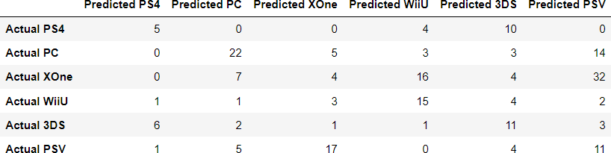
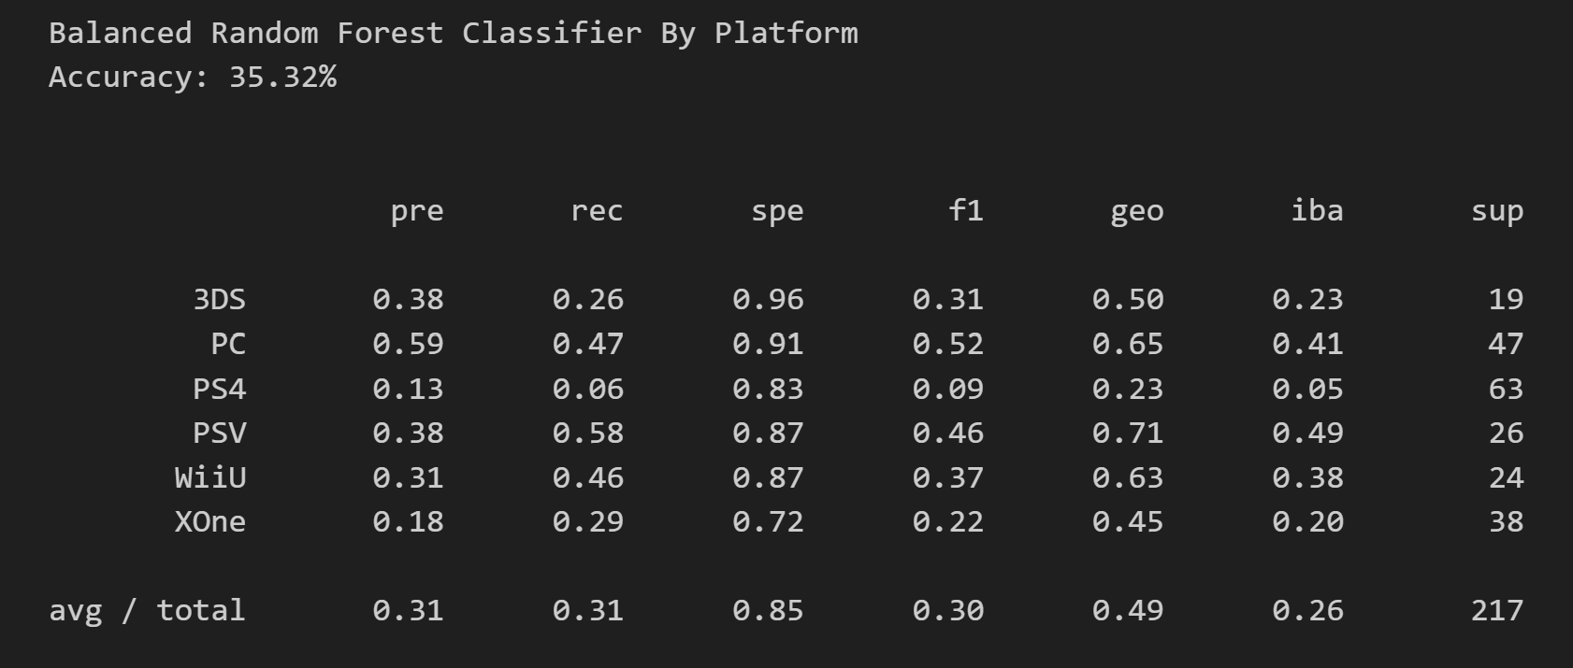

Appendix B
Black Random Forest Classifier Data frame and Imbalanced Classification Report by Rating
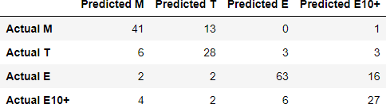
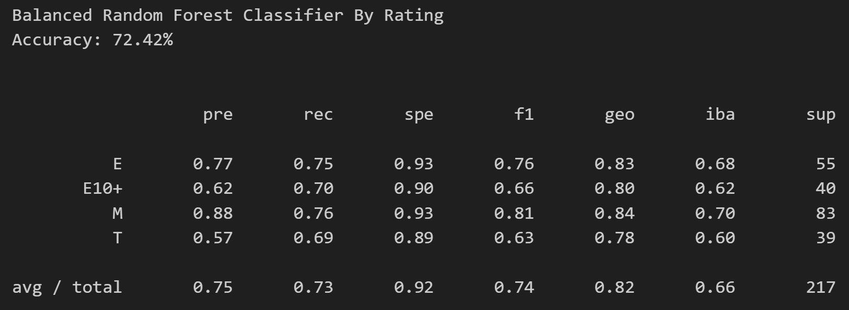

Appendix C
Black Random Forest Classifier Data frame and Imbalanced Classification Report by Genre
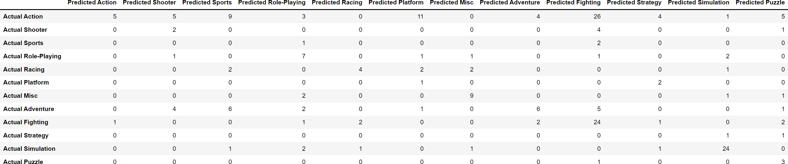
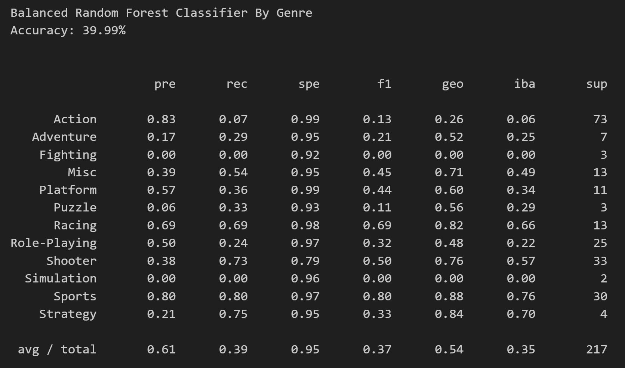

Appendix D
Easy Ensemble AdaBoost Classifier Data frame and Imbalanced Classification Report by Platform
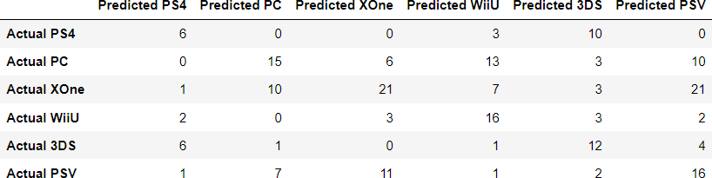
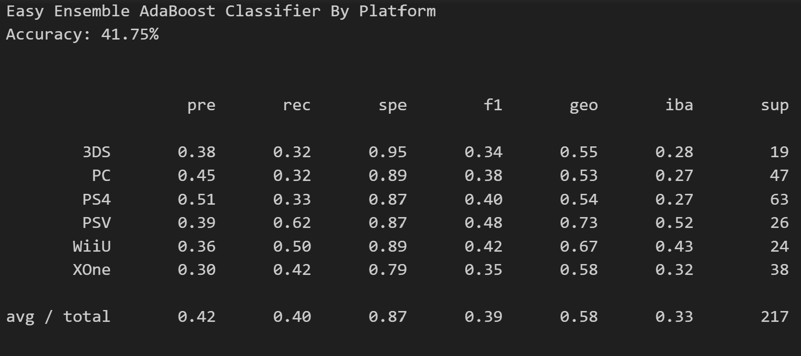

Appendix E
Easy Ensemble AdaBoost Classifier Data frame and Imbalanced Classification Report by Rating
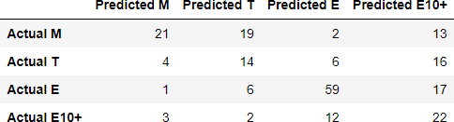
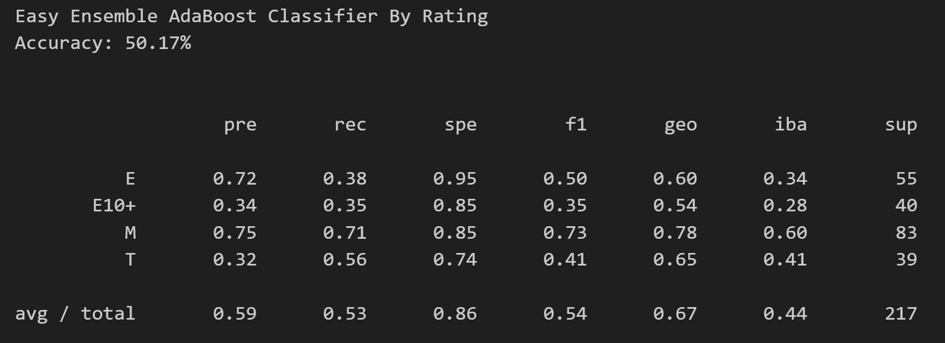

Appendix F
Easy Ensemble AdaBoost Classifier Data frame and Imbalanced Classification Report by Genre
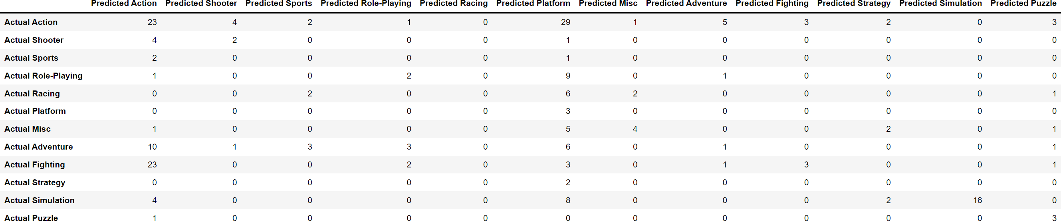

Appendix G
Naïve Random Oversampling Data frame and Imbalanced Classification Report by Platform
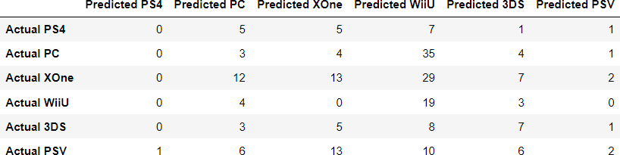
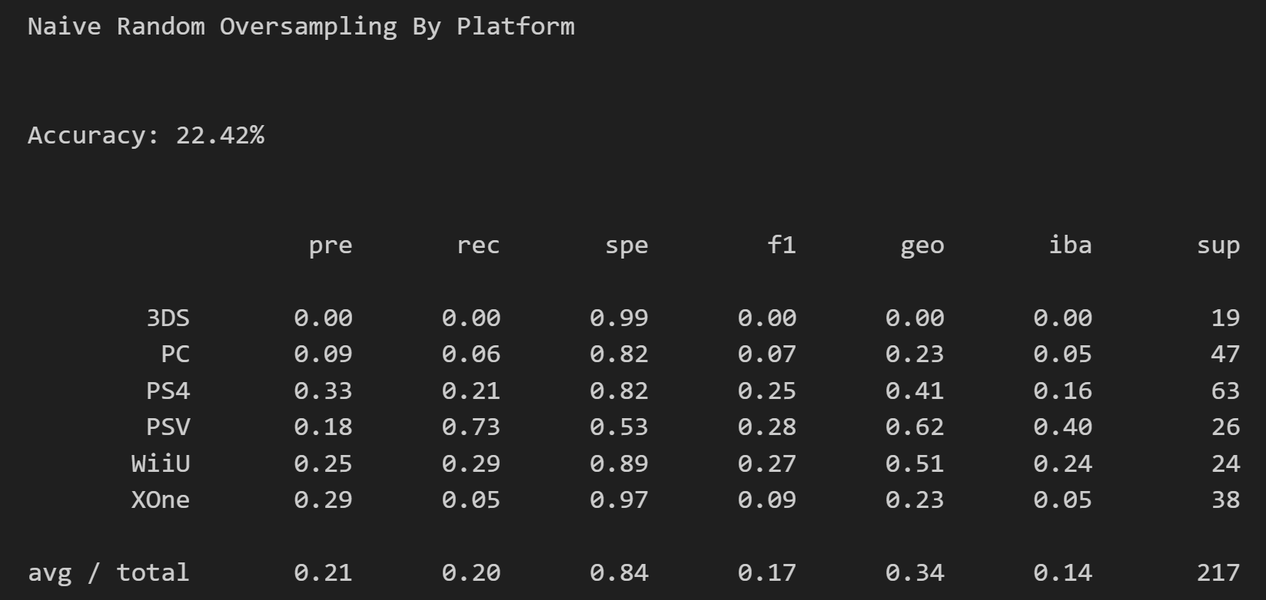

Appendix H
Naïve Random Oversampling Data frame and Imbalanced Classification Report by Rating
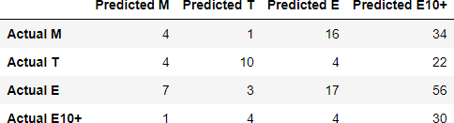
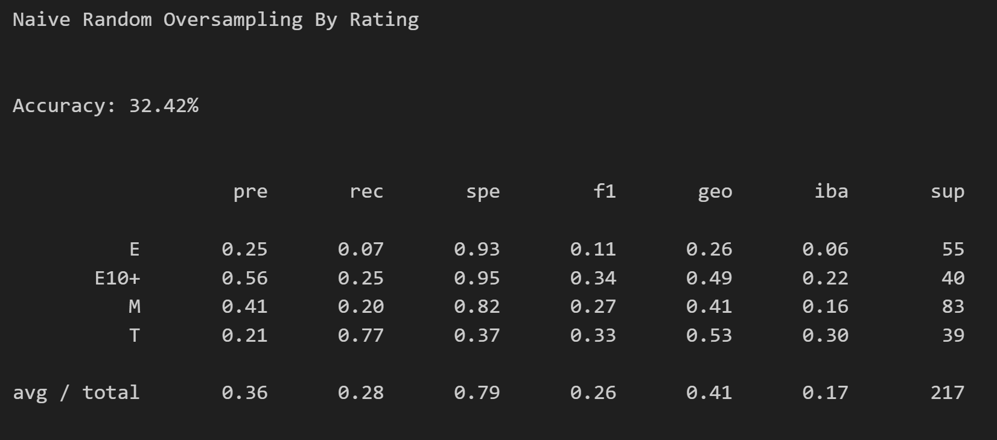

Appendix I
Naïve Random Oversampling Data frame and Imbalanced Classification Report by Genre
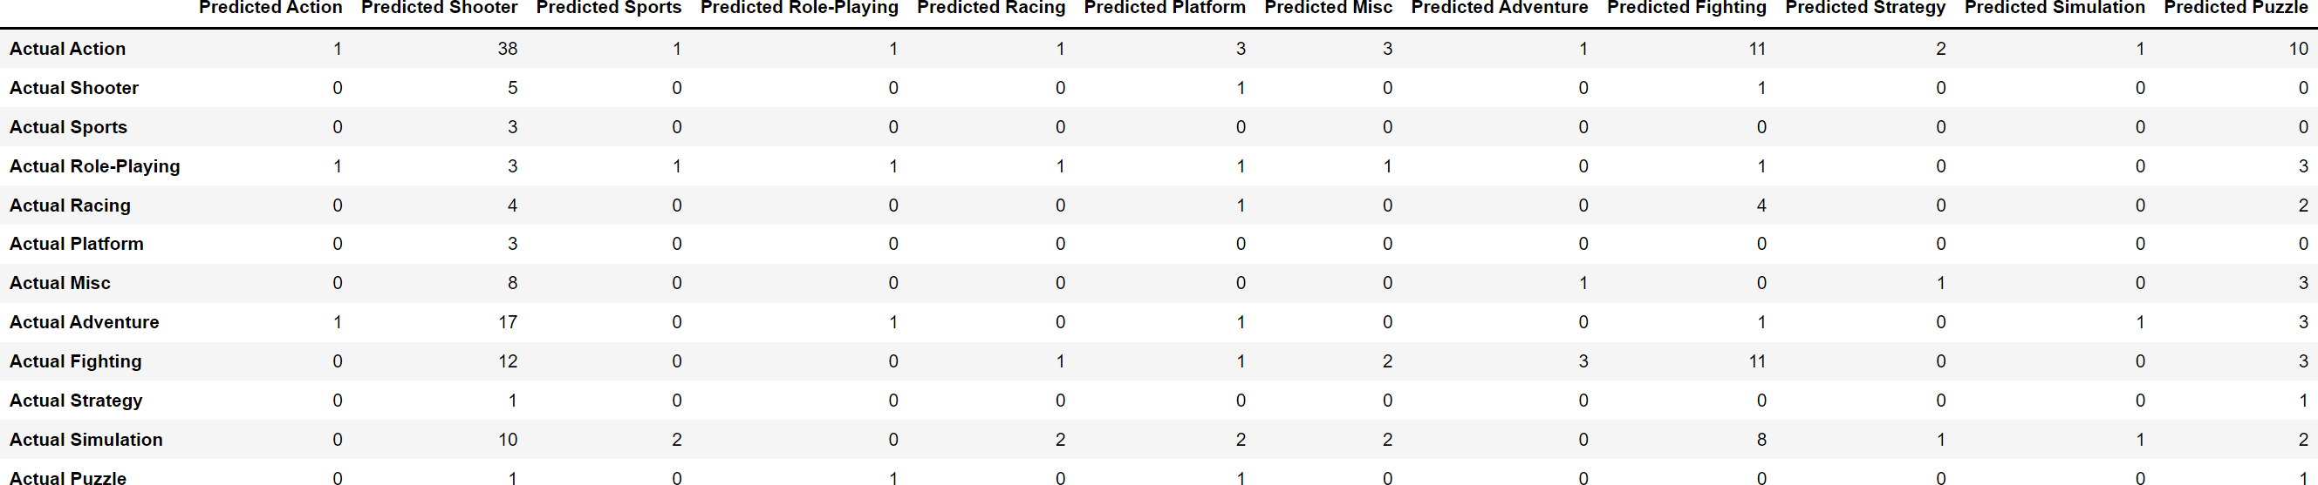
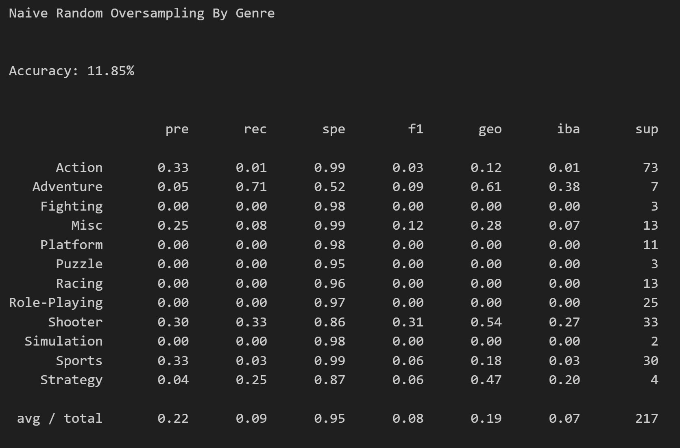
Appendix J
SMOTE Data frame and Imbalanced Classification Report by Platform
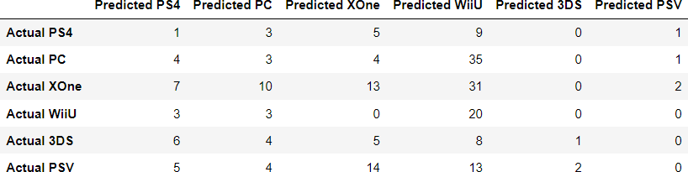
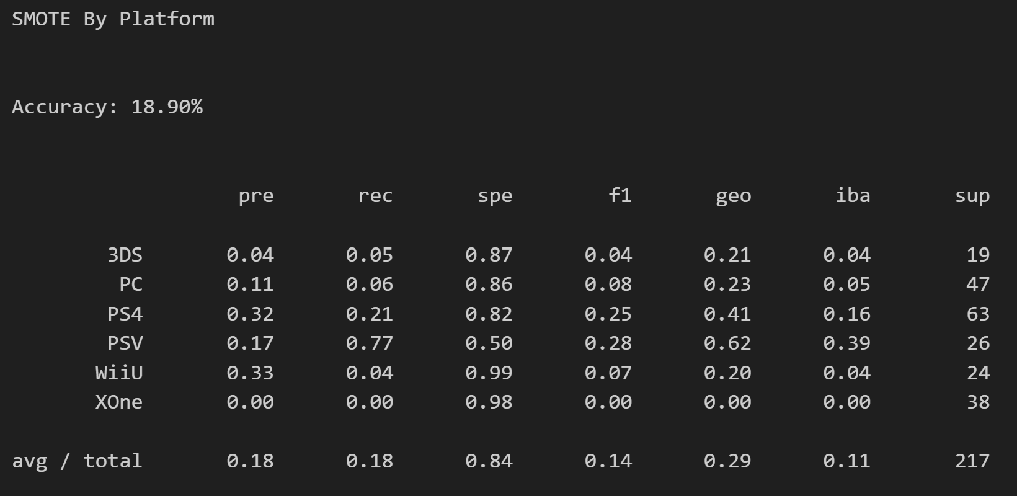

Appendix K
SMOTE Data frame and Imbalanced Classification Report by Rating
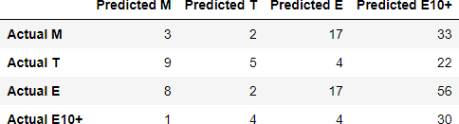
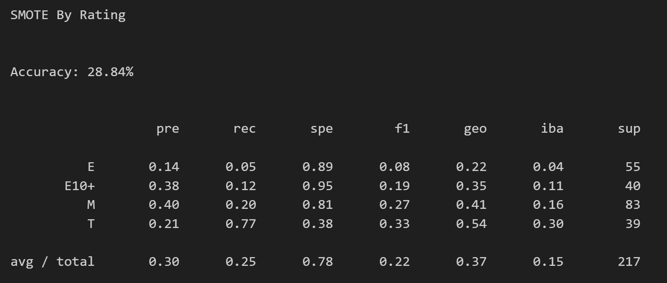

Appendix L
Undersampling Data frame and Imbalanced Classification Report by Platform
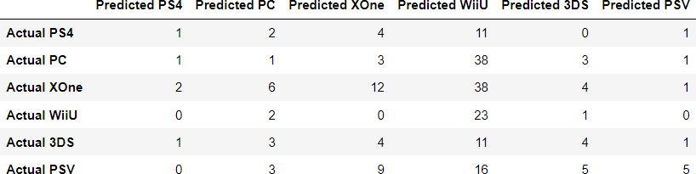
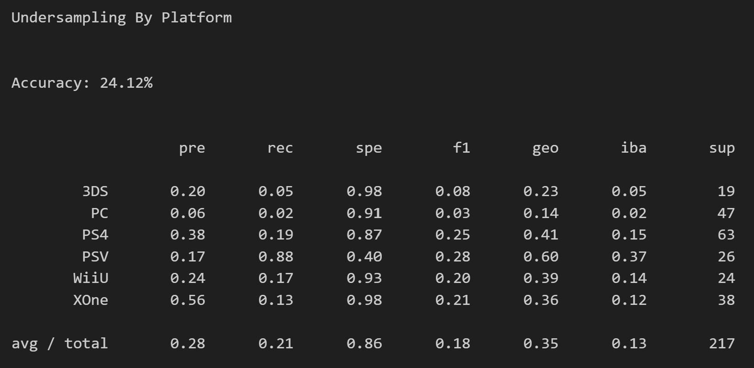

Appendix M
Undersampling Data frame and Imbalanced Classification Report by Rating
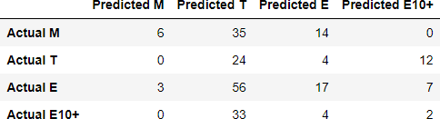
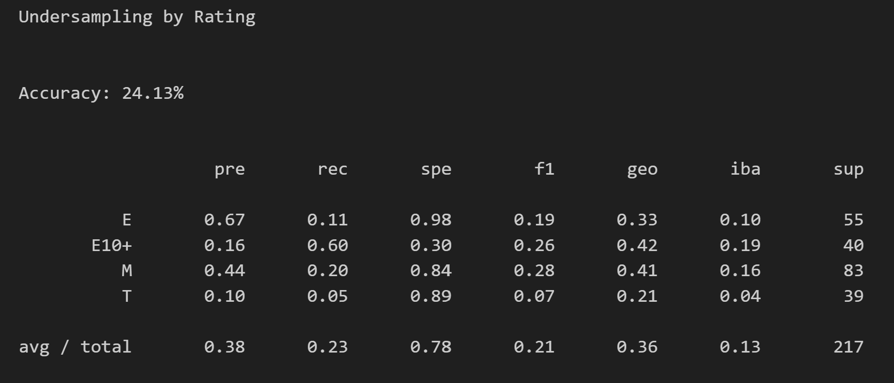

Appendix N
Undersampling Data frame and Imbalanced Classification Report by Genre
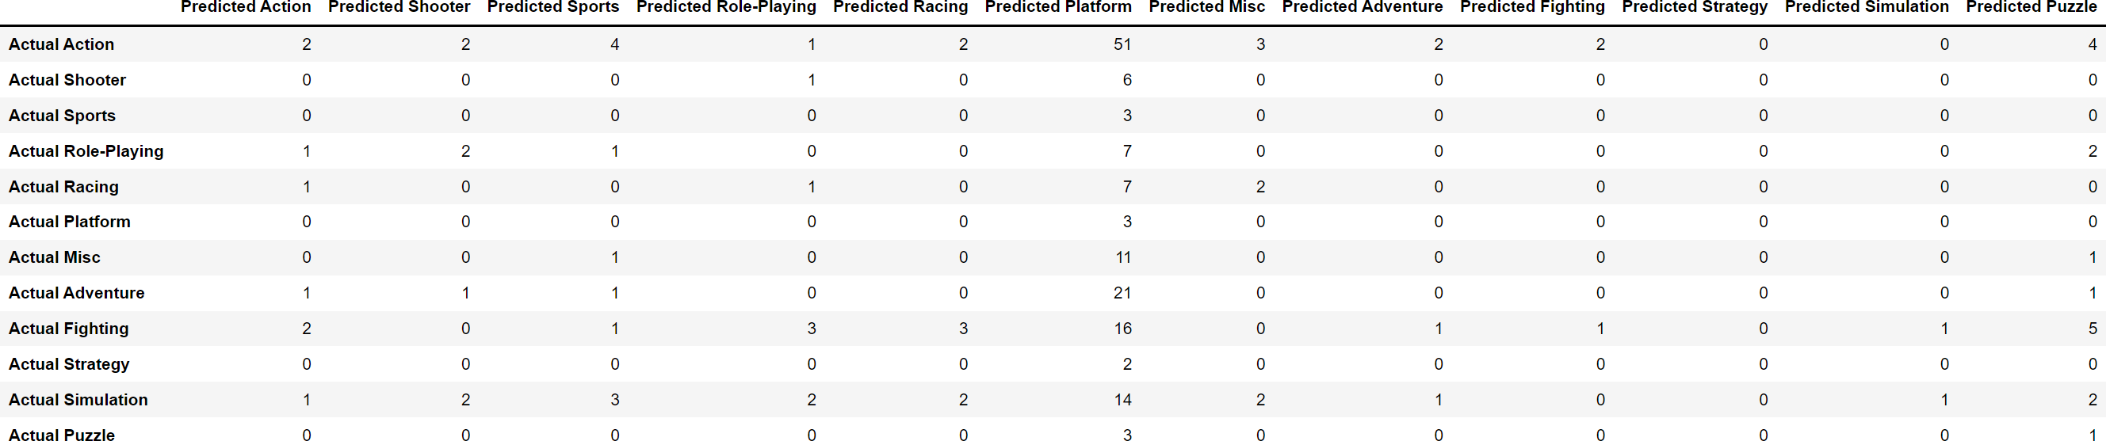
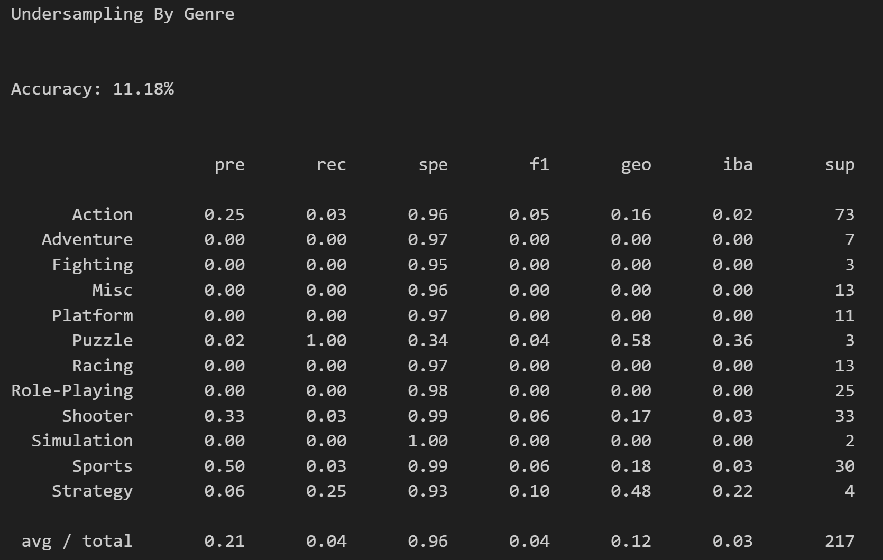
Appendix O
Combination (Over and Under) Sampling by Platform Data frame and Imbalanced Classification Report by Platform
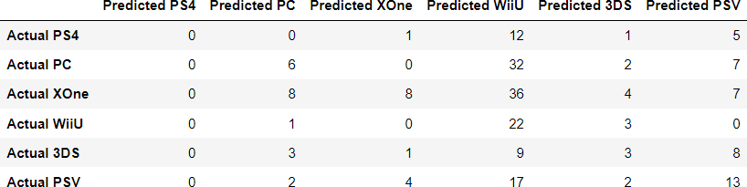
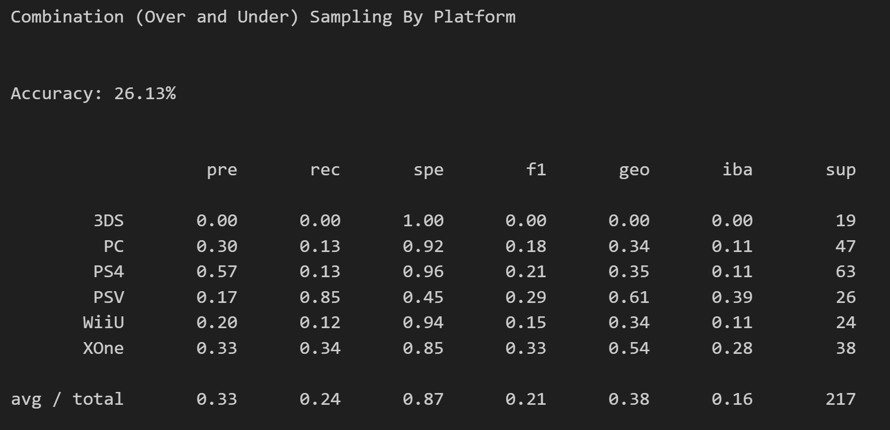

\Appendix P
Combination (Over and Under) Sampling Data frame and Imbalanced Classification Report by Rating
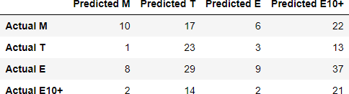
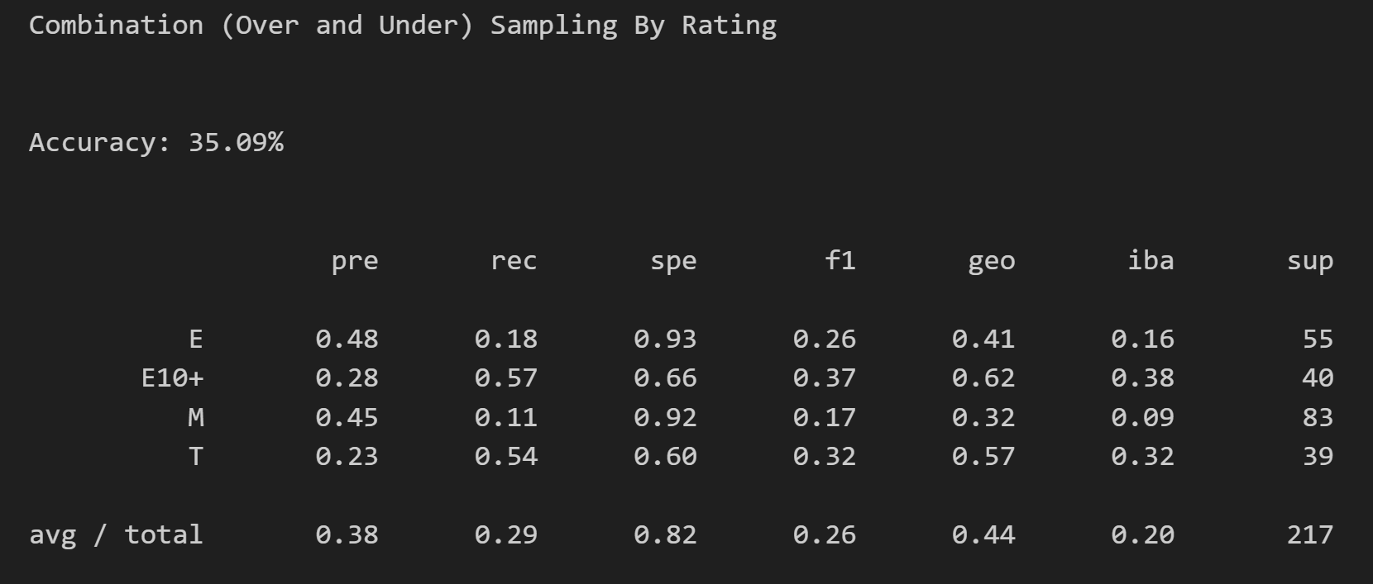

Appendix Q
Sales by Genre
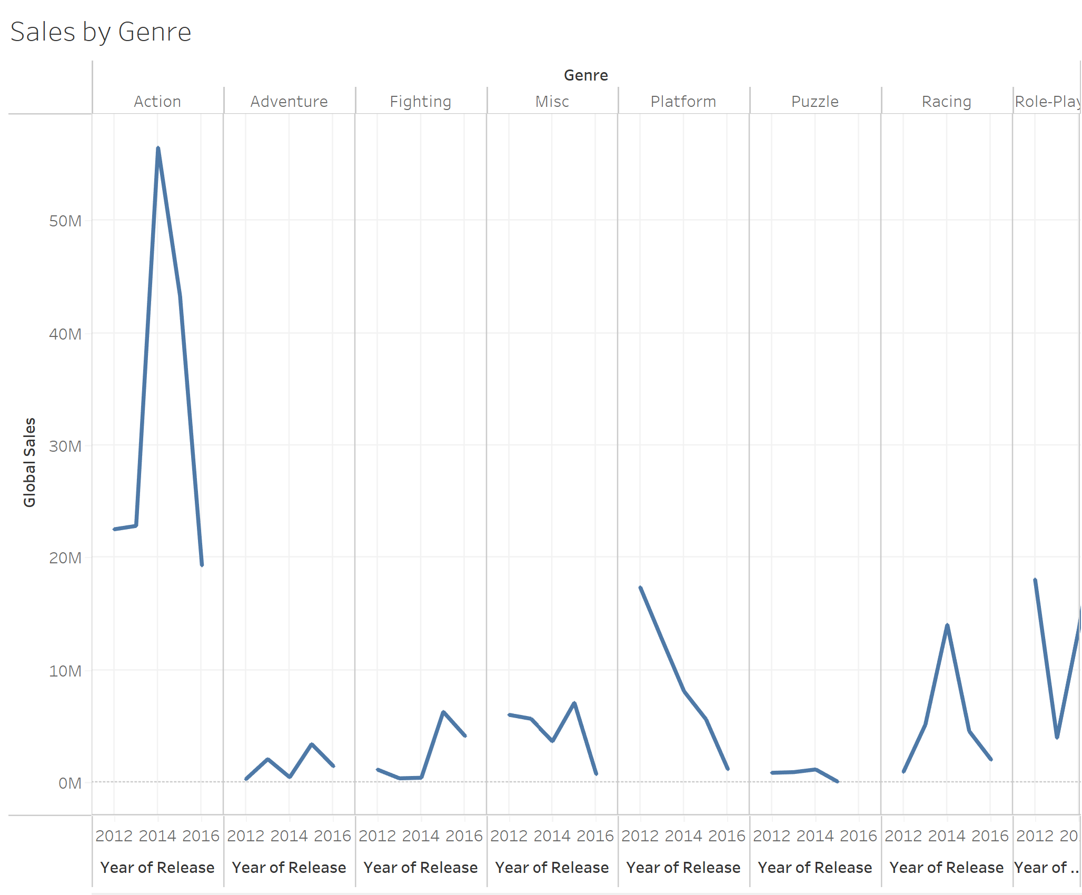

Appendix R
Sales by Platform
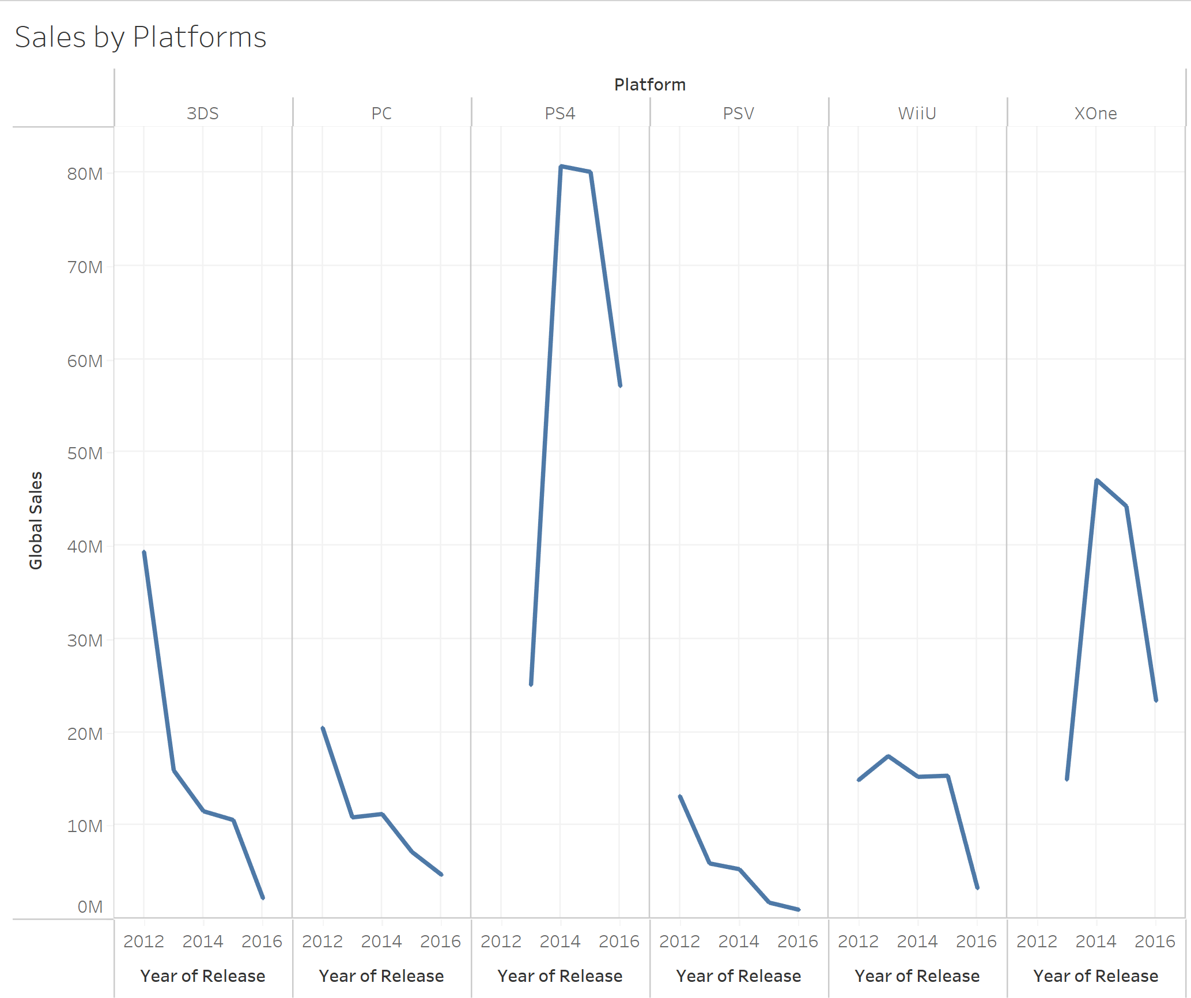

Appendix S
Sales by Rating
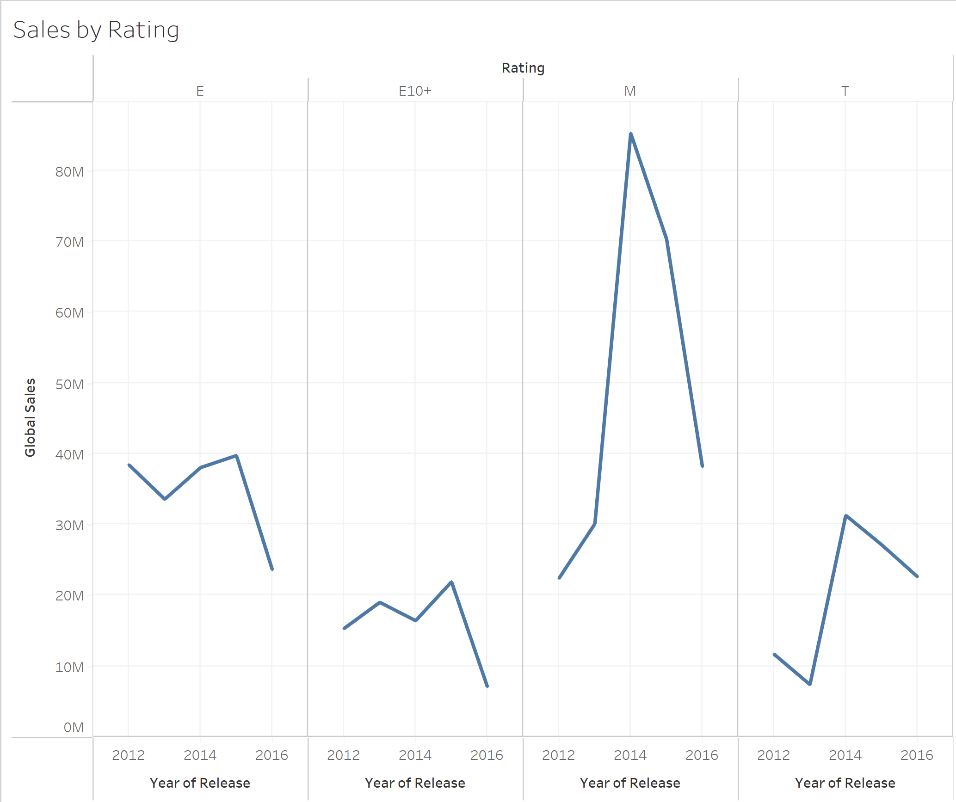

Appendix T
Sales by Year
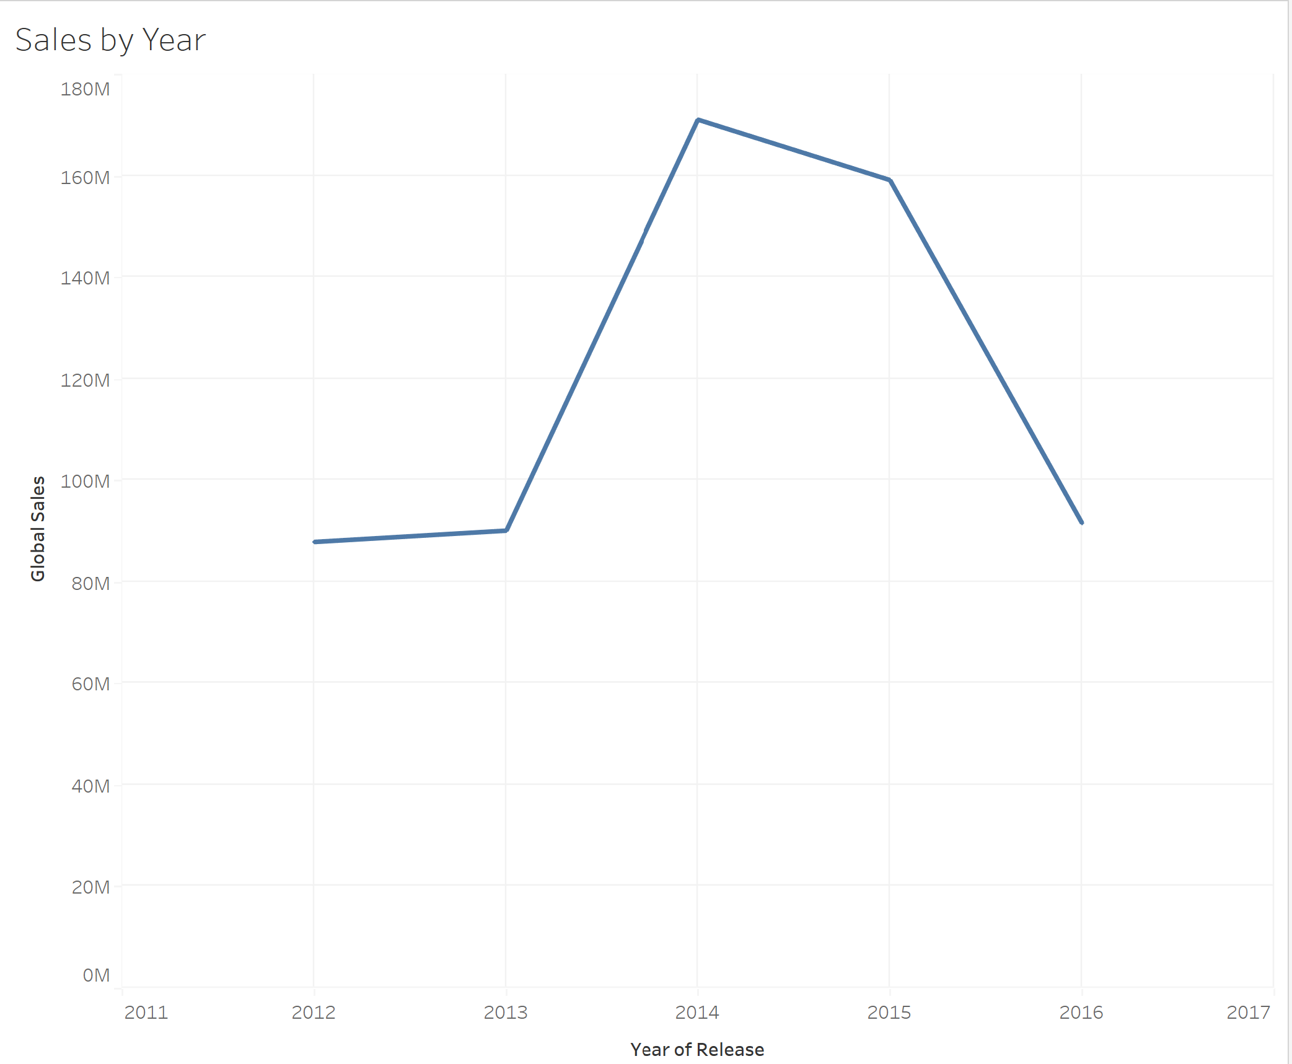

Appendix U
Count by Genre
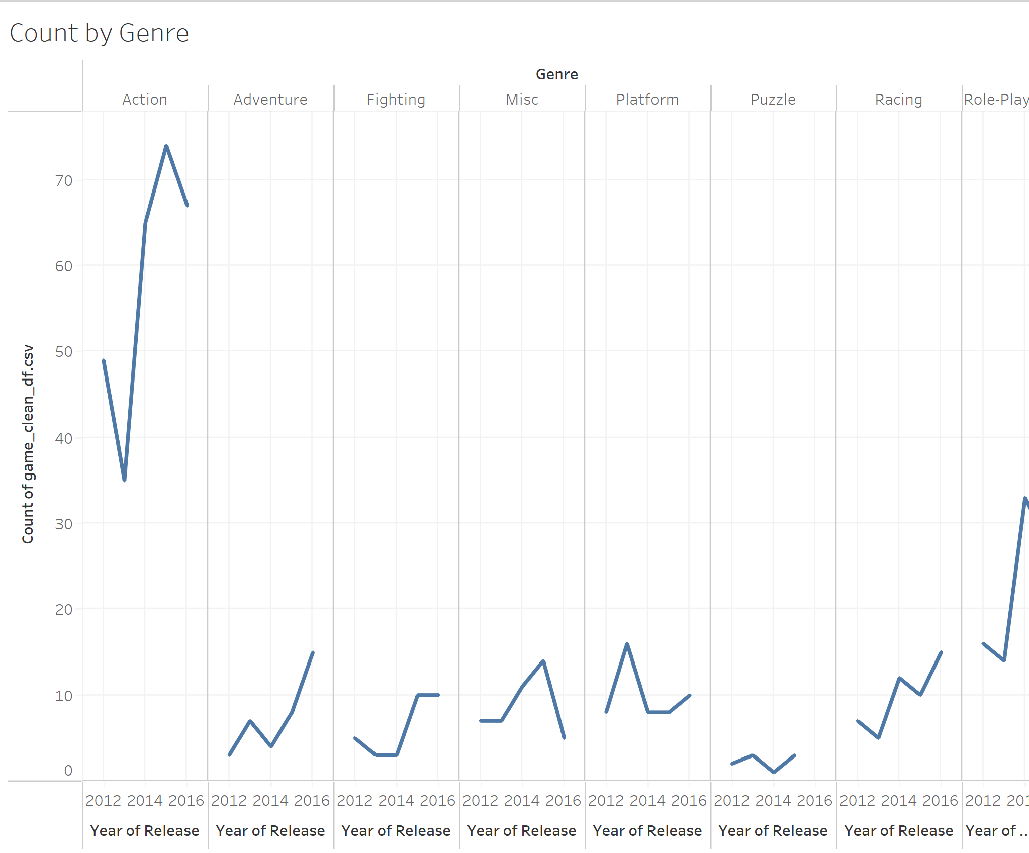

Appendix V
Count by Platform
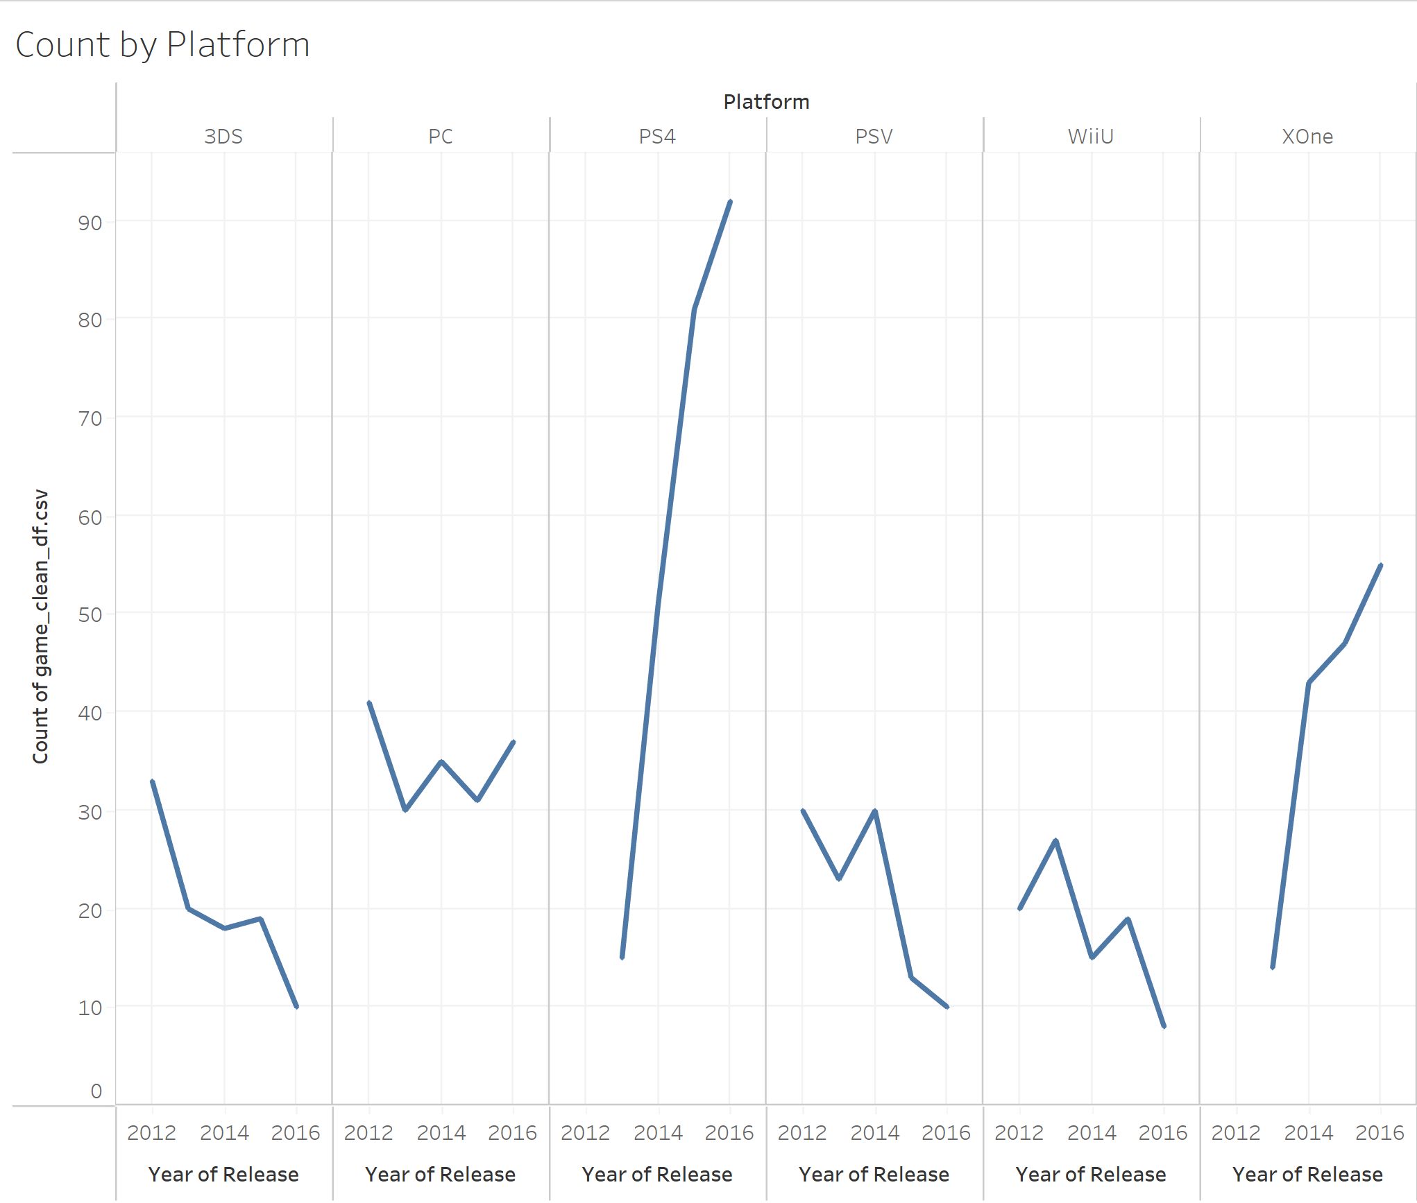

Appendix W
Count by Rating
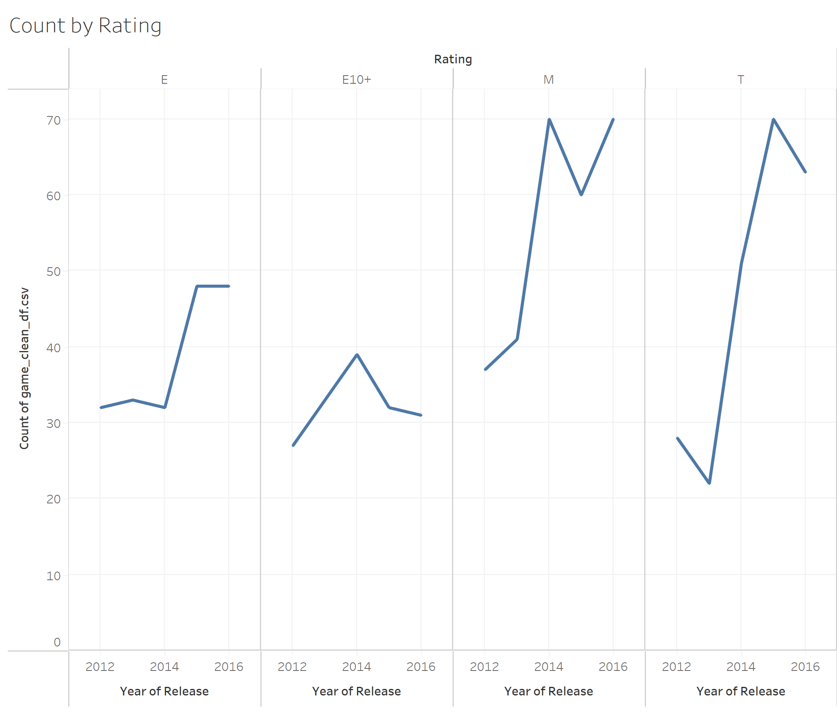

Appendix X
Count by Year
